D1 Report

Reasoning - What nodes are impacted by insertions

Worded Argument

When a new node is inserted into a Binary Search Tree, the nodes that may return different values for node_count() and value_range() are the new node and its ancestors along the insertion path from the root.

For example, when inserting 35 into the tree shown in the diagram, the insertion path is 50 → 30 → 40 → 35. The new node becomes part of the subtrees rooted at 40, 30, and 50. Therefore, the node count of each of these ancestor subtrees increases by one. Their value ranges may also change if the inserted value becomes a new minimum or maximum for the corresponding subtree.

Nodes that are not ancestors of the inserted node, such as 20 and 70 in the example, are unaffected. Their subtrees do not contain the newly inserted node, so neither their node count nor their value range changes.

Therefore, during insertion, the stored properties only need to be initialised for the new node and updated for its ancestors along the insertion path. Since the insertion path has a maximum length proportional to the height of the tree, these properties can be maintained without traversing unrelated subtrees.

Diagram
 | Diagram
Before Insertion | 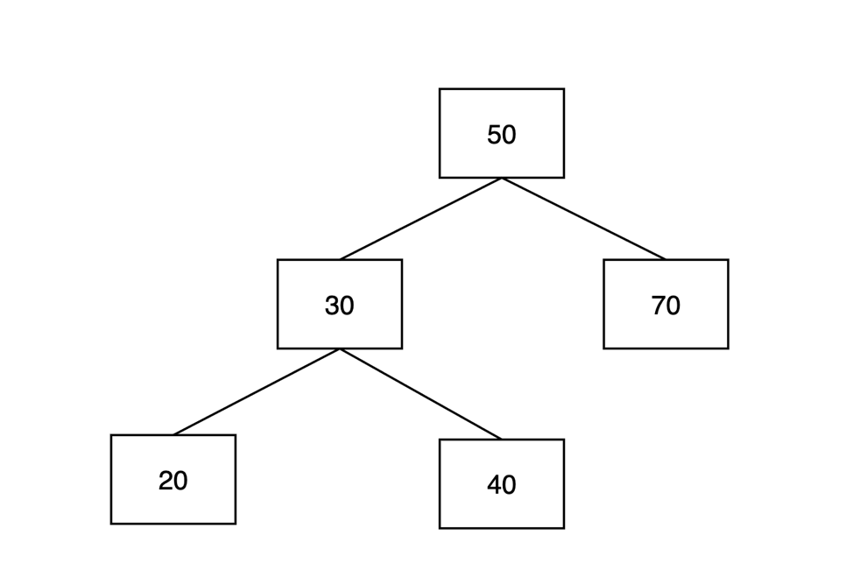
After Insertion | 